B. Tech Program Second Year

Course: Relational Database Management System

Course Code: IT2231

## “PHARMACY MANAGEMENT SYSTEM”

by

**Samriddhi Singh**

(209302338)

Under the guidance

of

**Mr. Ravinder Kumar**

Department of IT, School of Computing and IT, Manipal University Jaipur, Jaipur (Raj.).

**Department of IT**

**School of Computing & IT**

**Faculty of Engineering**

**Manipal University Jaipur, India**

May 2022

# Certificate

This is to certify that the project titled **“Pharmacy Management System”** is a record of the bona fide work done by **Samriddhi Singh** (Reg No: 209302338) submitted for the partial fulfilment of the requirements for the completion of the Relational Database Management System(IT2231) course in the Department of IT of Manipal University Jaipur, during the academic session January-June 2022.

|  |
| --- |
| *Signature of the mentor* |
| Mr. Ravinder Kumar  Department of IT |
| *Signature of the HoD* |
| Dr. Pankaj Vyas  Head of the Department  Department of IT |

# Abstract

Medicines and health products have formed an indispensable part of our lives. A well-functioning health system is built on having trained and motivated health workers, a well-maintained infrastructure and a reliable supply of medicines and technologies. Managing pharmacies manually can be a tedious task where there are many chances of human errors. This pharmacy management project makes the task easier by inserting, modifying, and removing the information of the available medicines in the store in a database. One can easily sort, update, and access the data of medicines on various basis such as manufacturing date, expiry date, medicines available in stock, mrp and check if they are out of stock. The pharmacist can easily update the data for stock of medicines whenever required. One can easily generate summary on selected basis such as expired medicines or medicines out of stock. The program thus helps the user to easily learn about the data of medicine and health supplements as required. It also provides data security by allowing only known users to login and edit the database while providing another window to the users for searching according to their need where the medicines and health supplements are sorted on the basis of their purpose.

# Introduction

Like many other professions, pharmacy is changing and adapting to latest methods of health delivery. The practice of pharmacy today is one of the most important in the delivery of health services, and pharmacists are the health professionals who have the most detailed knowledge of medicines. Thus, managing a pharmacy can be a tedious work if not organised properly and for a pharmacist to remember all the details accurately is not always possible where there are chances of error as well. To eliminate these errors, to improve the accuracy of information and for proper organization of information of medicines and health supplements, this project Pharmacy Management makes it easier to access the details of various medicines available in stock, the easiness to update the information of medicines such as its quantity, expiration date, manufacturing date and price. One can easily generate a list based on various categories and hence can easily sort out the medicines as per the requirement. This will not only maintain the accuracy but save time as well, therefore increasing the efficiency of a pharmacists’ work. Procurement and distribution play a critical role in the provision of cost-effective quality of pharmaceutical care.

Highlights of the project –

* **Easy insertion:**  Information related to new stock of medicines and health supplements can be easily inserted into the database by entering the relevant information in the window provided.
* **Quick Update:** Modifications related to the medicines and health supplements can be updated anytime by entering all the necessary details in the entry boxes.
* **Delete:** As per the necessity and requirement of the pharmacist, the expired medicines can be deleted from the database by entering the relevant details of the medicine and health supplements.
* **Detailed view:** Can view the details of the medicines available in stock, their expiration date, manufacturing date, price, quantity along with their specified code.
* **Quick Sorting:** Based on the specified criteria, the user can get the summary of the medicines that are to be removed from the database and hence can be easily sorted out in the pharmacy as well.
* **Data Security:** The login window with username and password ensures the security of the pharmacy management system by ensuring that only the registered authorities can access the database and can make the required changes in the database.
* **Quick Search Result:** A person can click on the provided various buttons given in the search window as per the choice and requirement to view the list of medicines and health supplements based on the selected criteria.

# Methodology/Algorithm

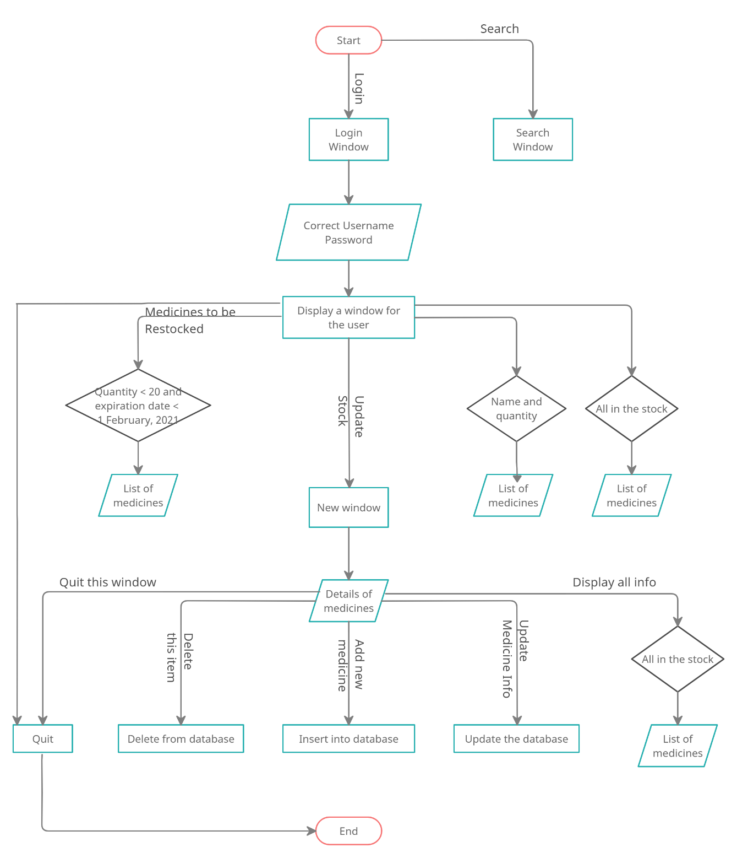

**Functions:**

1. **Update Stock:** Directs the user to a new window “Medicine Stock” to enter the details of the medicines and performing the following functions as per the requirement –
2. **Add New Medicine:**  Inserts new medicines and its details in the database. This is useful when we need to update the new stock of medicine in pharmacy.

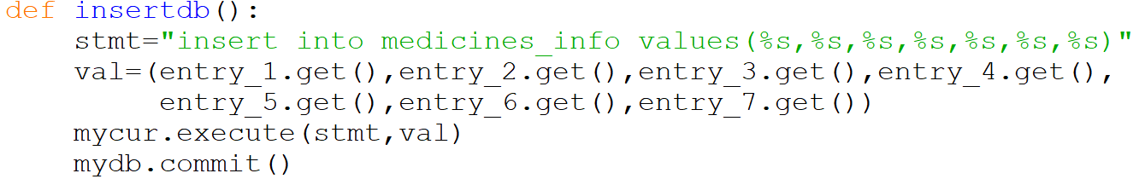

1. **Update Medicine Info:** By entering the related details of the medicine in the entry boxes, the information can be updated in the database whenever required.

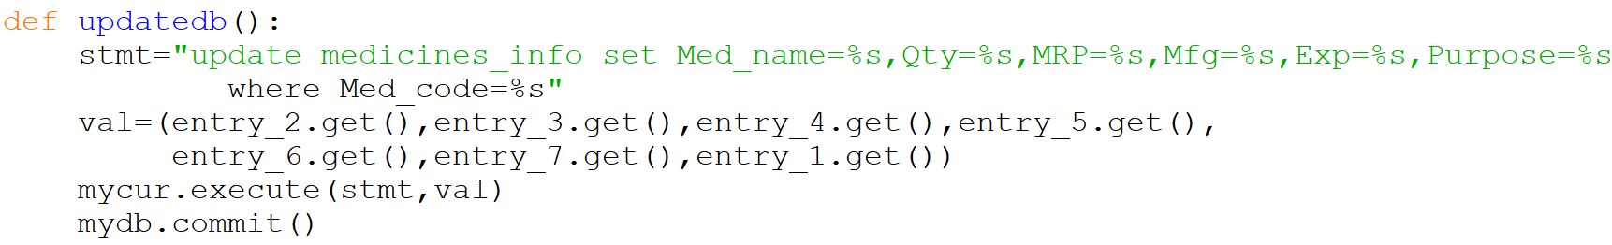

1. **Display all info:** Allows the user to view all the medicines’ details available in the pharmacy on a new window.

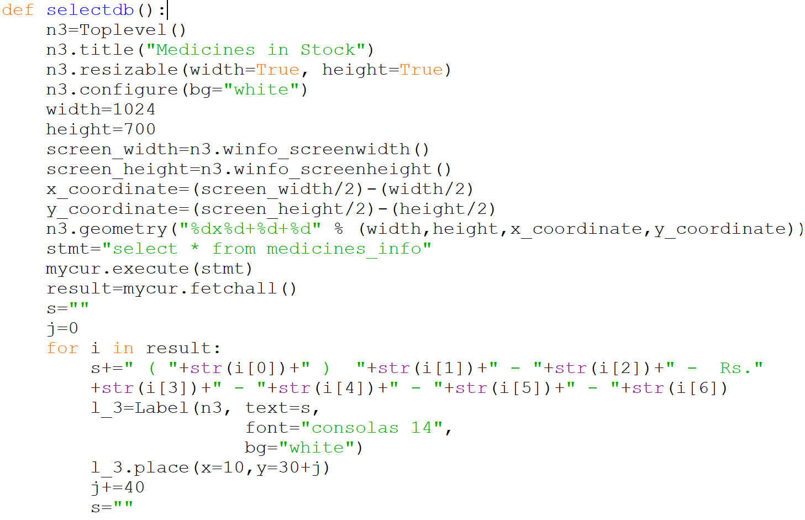

1. **Delete this item:** According the details entered in the entry boxes related to medicines’ name, price, expiration date, manufacturing date and quantity, the information relating to that medicine is deleted from the database permanently.

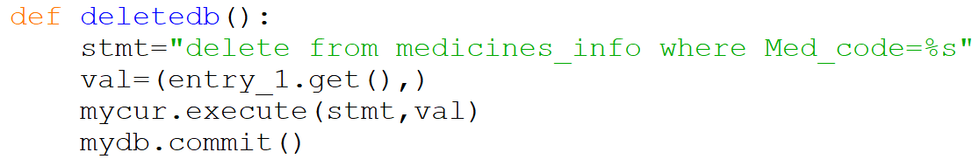

1. **Quit this window:** Closes the current window “Medicine Stock” when clicked.

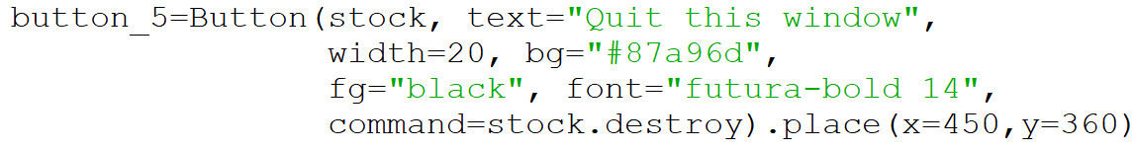

1. **Medicines to be restocked:** Displays a list of the medicines that are to be restocked in a new window. The criteria being set where the quantity of a particular medicine is less than 20 and expiration date less than 2020.12.01.

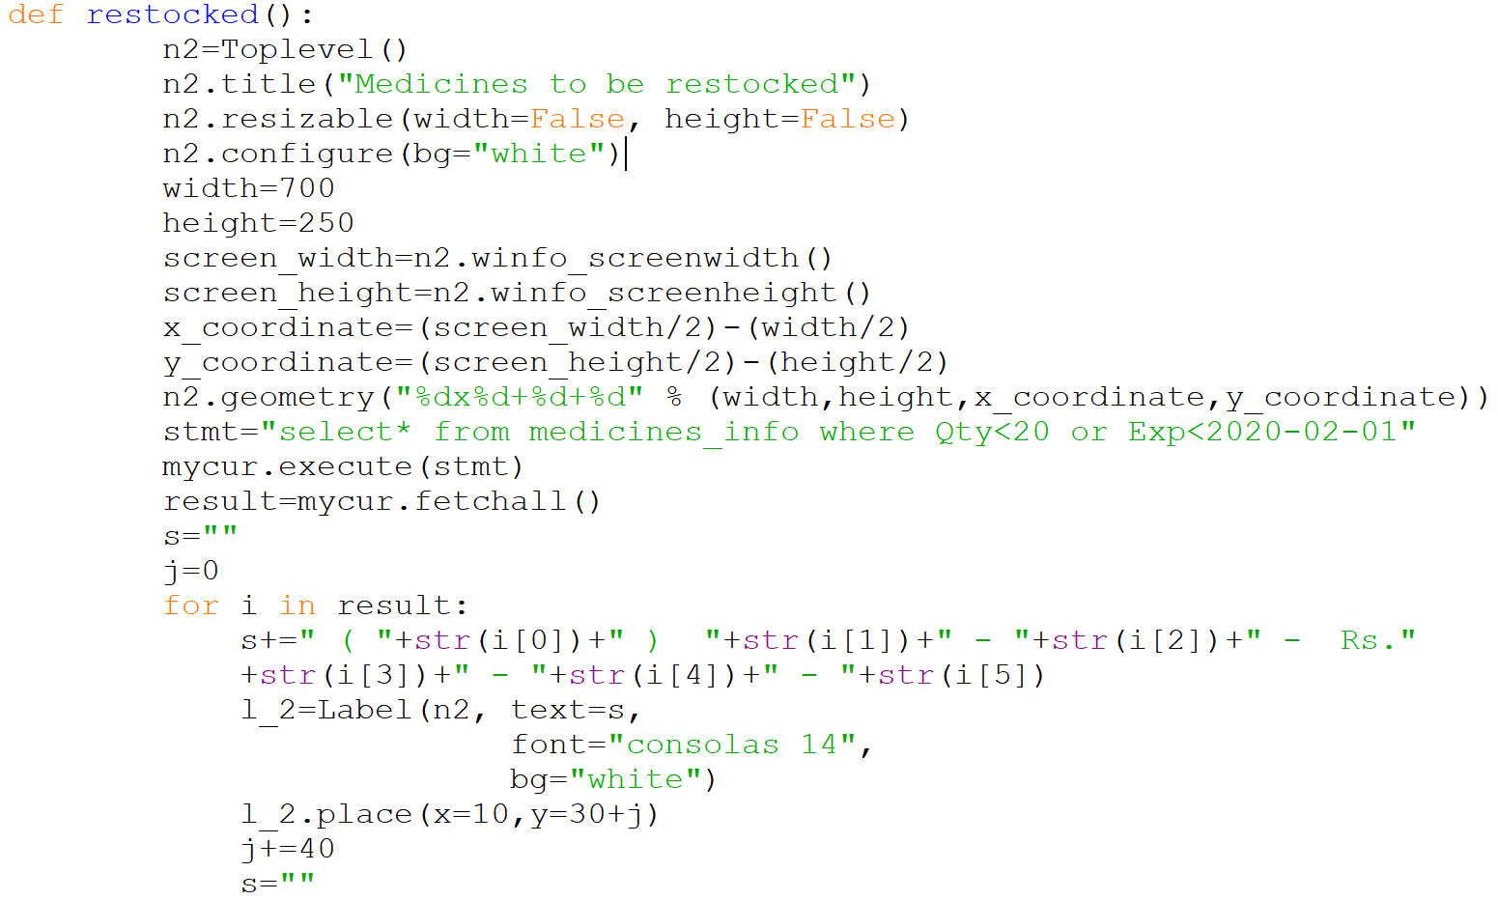

1. **Display all in Stock:** Displays the list of all the available stock of medicines in the database in a new window.
2. **Quantity in Stock:** Displays the medicines’ names and its quantity present in the database in a new window.

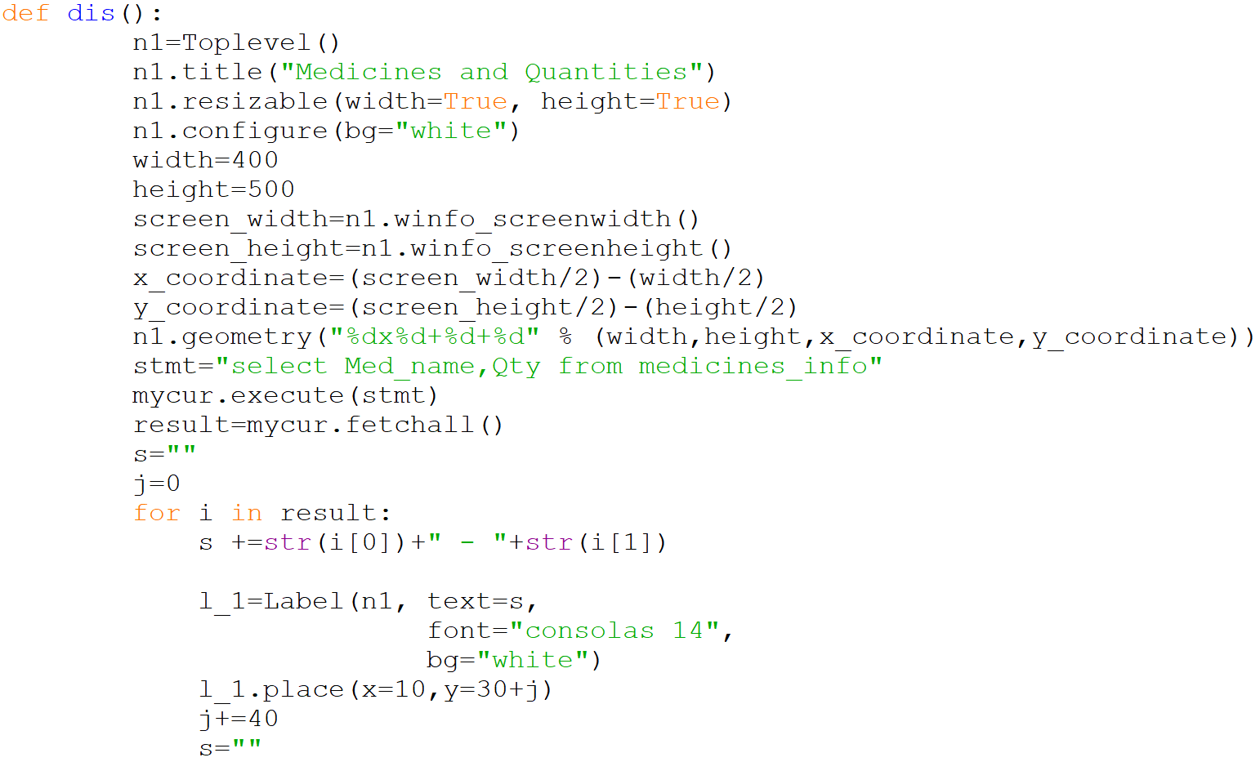

1. **Quit:** Closes the current window “Pharmacy Management System” which is opened.

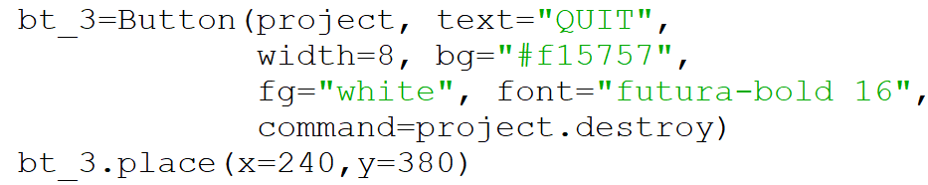

# Searching : Based on various categories, the list of medicines and health supplements will be displayed in a new window.

# 

# Similarly, other functions are created for sorting and displaying the medicines and health supplements in a new window according to the selected criteria such as anti-inflammation, cough, fever, anti-flu, baby products etc.

# Results and Discussions

**Welcome Window**

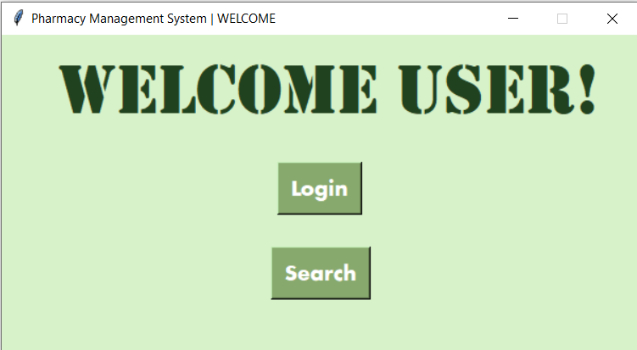

**Login Window**

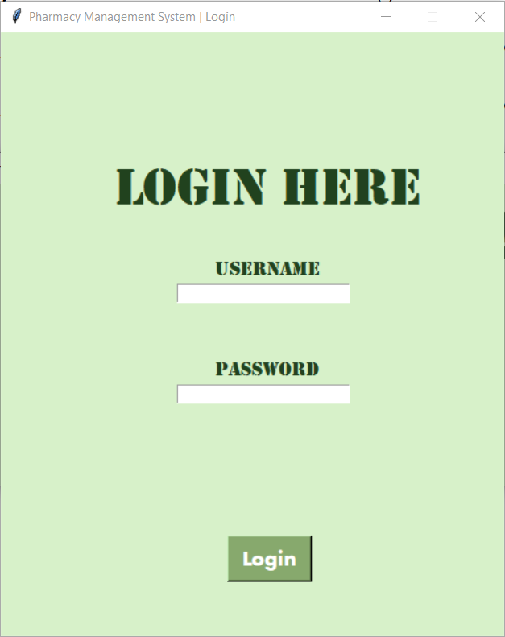

**Admin Window**

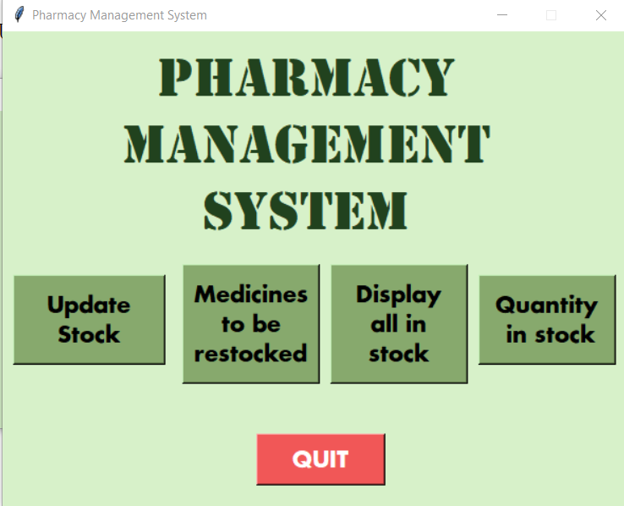

**Medicines to be restocked.**

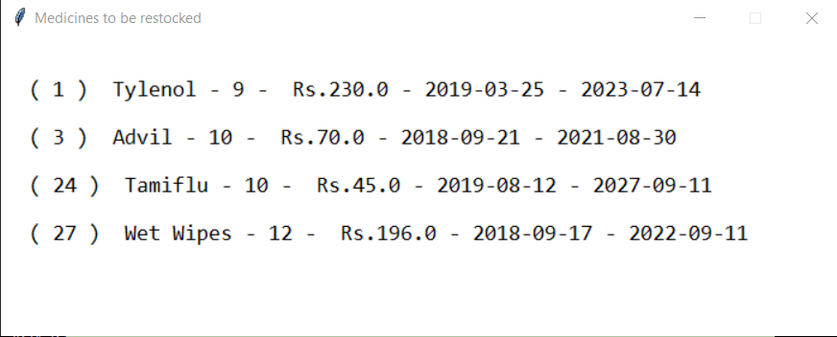

**Display all in stock**

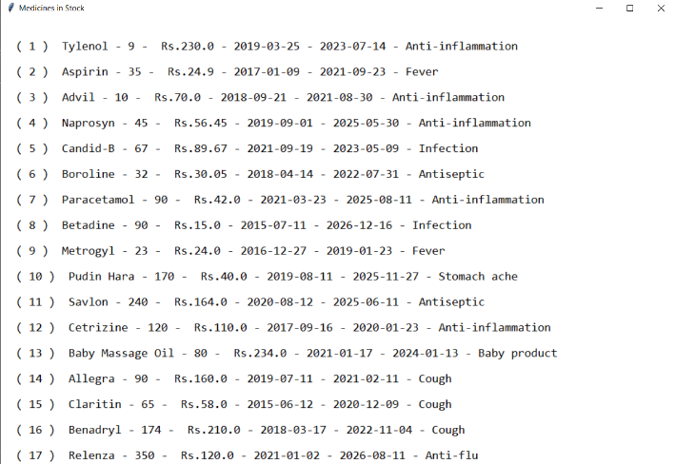

**Quantity in stock**

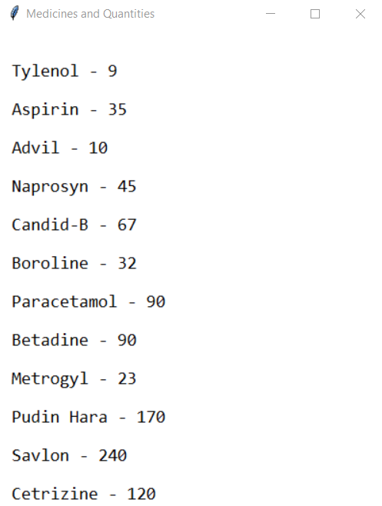

**Update Stock Window**

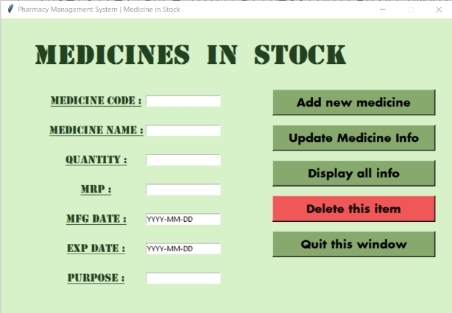

**Add new medicine.**

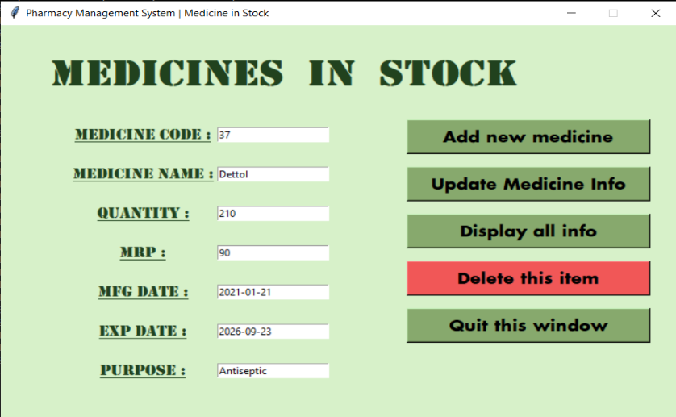

Medicine “Dettol” with code 37 inseted into the database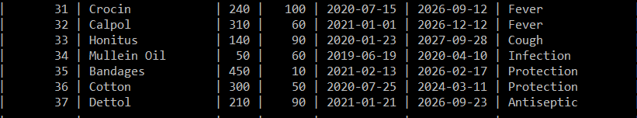

**Update medicine info**

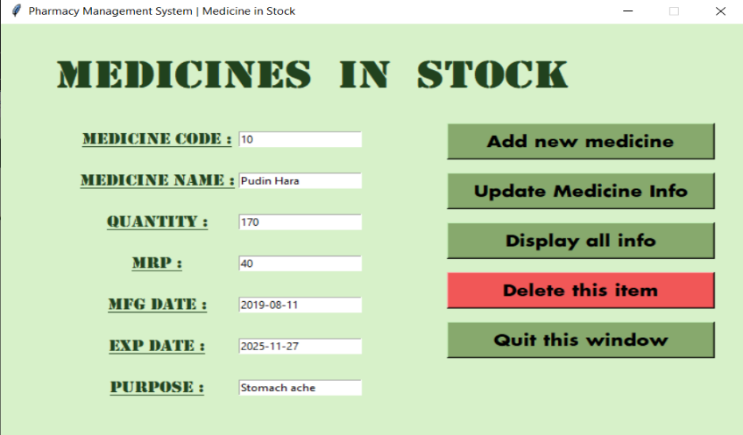

Before

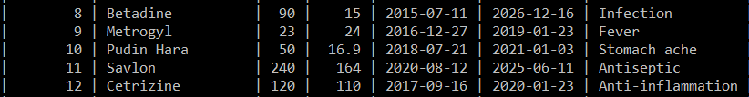

Details of medicine “Pudin Hara” updated

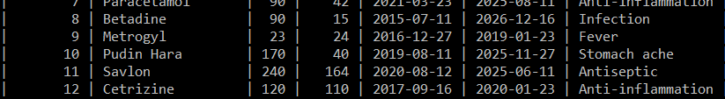

**Delete this item.**

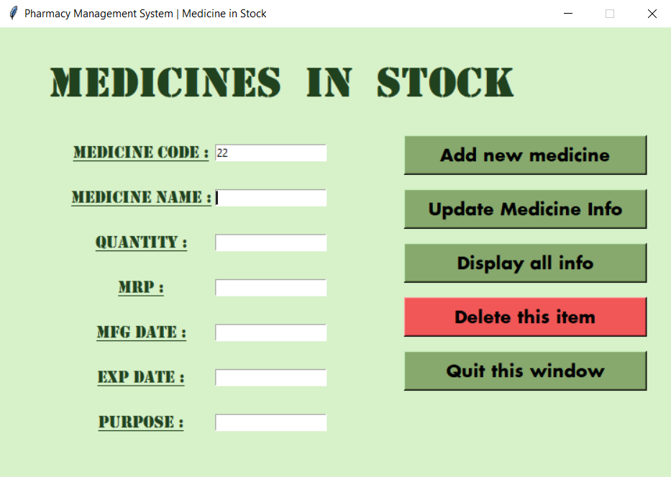

Medicine with code 22 deleted.

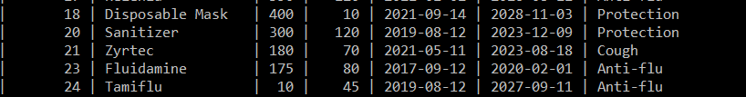

**Search Window**

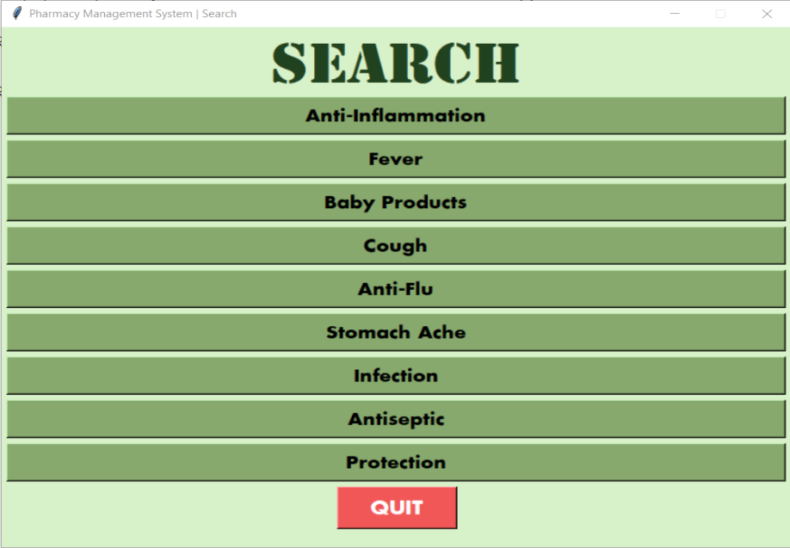

**Search Results**

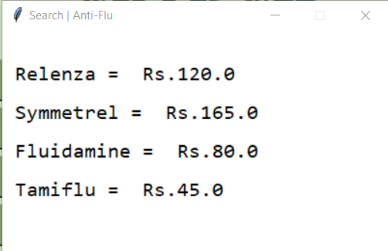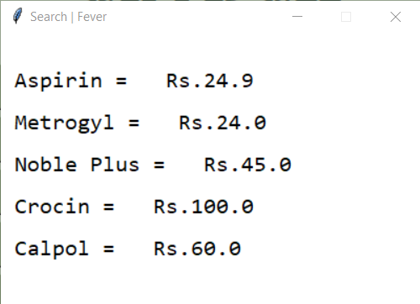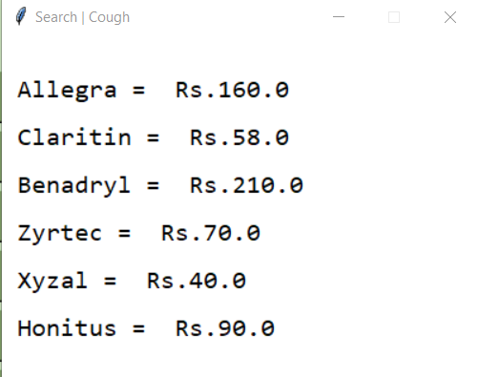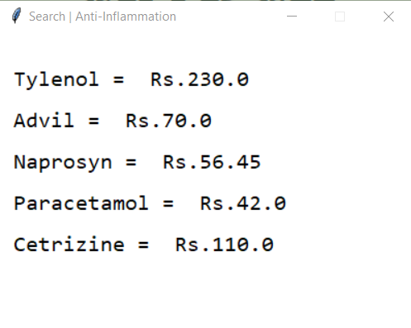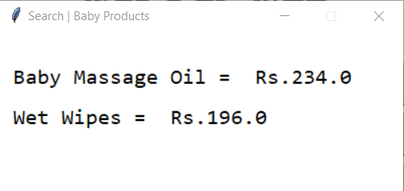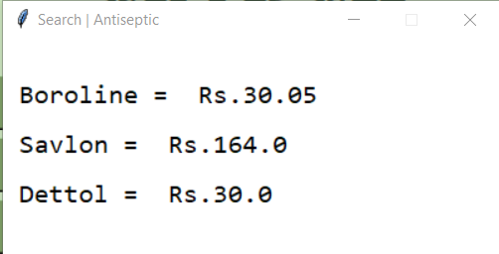

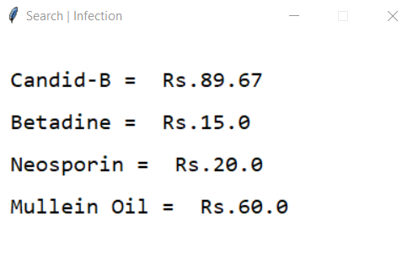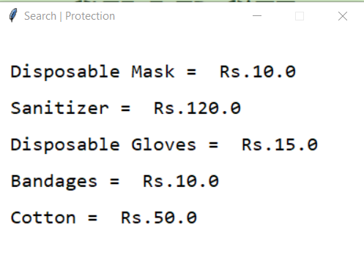

# 

# Conclusions

This project, Pharmacy Management System aims on creating a database while at the same time maintaining the data security. With the help of login window, only the verified users can view the database and make the necessary changes very easily just by the help of few buttons where the username and password are “admin” and if wrong username and password is entered then the login window closes automatically.



Based on one’s need a person can also display the names of medicines and health supplements by clicking on the selected criteria buttons.

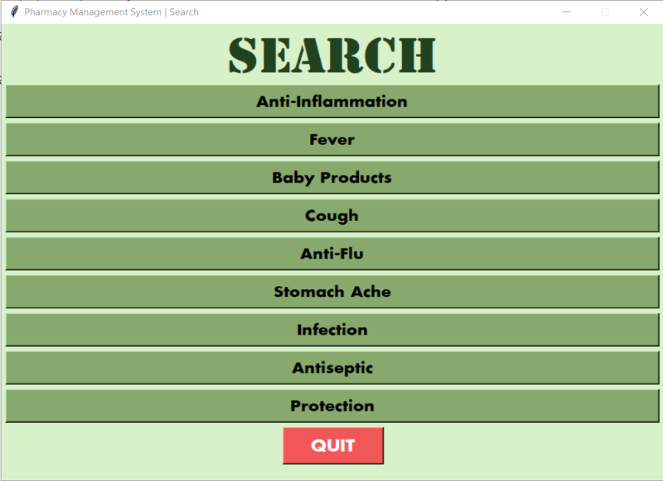

The main screen of Welcome User gives the choice to select between login and search and thus clicking on the required button will guide the user to the next page.



The following two windows help the user in maintaining the database as per the requirement by displaying the summarized lists based on given criteria and entering the required details for a medicine to be updated in the database.



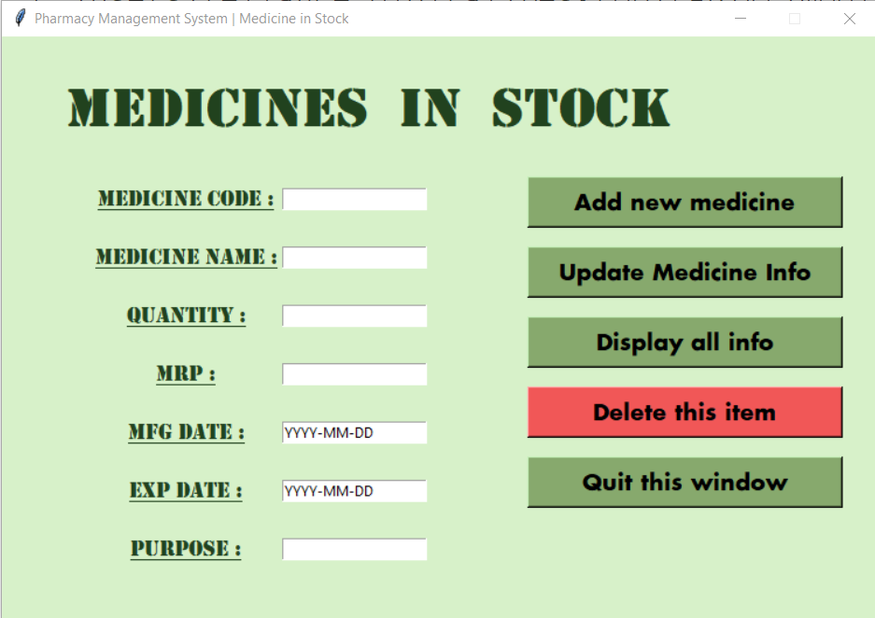

# Future Prospects

With furthermore improvements this project Pharmacy Management System can be used in every pharmacy for easy maintenance of the records of various medicine and health supplement stocks. The data security can be increased by various methods such as by encryption and decryption or by registering the names of the candidates accessing the database and storing it in the database in another table. A table can be made where username and his/ her search history will be stored which will make it convenient for the pharmacist to know the in-demand medicine and health supplement. Thus, we can generate a graph showing the growing demand and decreasing demand of the medicine and health supplement and accordingly the stock of the medicines can either be increased or decreased in the respective pharmacy. This will also increase the profit of the pharmacy.

A search bar can be added in the search window for the easy sorting of medicine and health supplement from the database. Online access of the search window can be made so that the customers coming to the pharmacy can access whether the required medicine is there in the pharmacy or not, thus saving time of both the pharmacist and the customer. Along with searching for medicine and health supplement, the symptoms can also be searched through and relevant information regarding medicine and heath supplement can be provided.

The GUI of the project can be improved to make it more interactive and attractive, thus increasing the customer response.

This can become an online pharmacy where the customer can directly search for the required medicine, order it and get it delivered as soon as possible. At the same time, the price, the manufacturing date, and the expiration date will be displayed, hence the customer will know the important details regarding the medicine and health supplement.

# References

1. Sumita Arora, *Computer Science with Python Textbook for Class XII, (***2019)**, 12th Edition, Dhanpat Rai & Co
2. Sumita Arora, *Computer Science with Python Textbook for Class XI, (***2019)**, 12th Edition, Dhanpat Rai & Co.
3. <https://www.geeksforgeeks.org/python-tkinter-tutorial/>
4. <https://www.javatpoint.com/python-tkinter>

# Acknowledgement

On the very outset of this report, I would like to express my extremely sincere and heartfelt obligation towards all the personages who have helped me in this endeavour.

The sources and final outcomes of this project required a lot of guidance and assistance from many people, and I am extremely fortunate to have got this all along the completion of my project work. Whatever I have done is only due to such guidance and assistance and I would not forget to thank them.

I respect and thank Ms. Vineeta Soni, for giving me an opportunity. She provided me with valuable guidance, encouragement and her suggestions have contributed immensely to the evolution of my ideas on the project at each and every step.

I also extend my gratitude to Manipal University Jaipur for giving me this opportunity to present my ideas through a project.

This project not only made me more knowledgeable but also provided a lot of fun in learning and using new functions.

Thank You